Environment (Wales) Act 2016 Part 1 - Section 6
The Biodiversity and Resilience of Ecosystems Duty Report 2022
Name of Town or Community Council: Mumbles Community Council
Introduction and Context
- Mumbles or Mwmbwls, is a seaside community in South Wales, often described as ‘The Jewel in Swansea’s Crown’ or ‘The Gateway to Gower’. In the Sunday Time’s: 2018 Best Places to Live in the UK Report, Mumbles was listed as the best place to live in Wales.
- Mumbles covers an area of 11.4km², its population is 16,600, making the population density 1,449/km².
- Mumbles Community Council covers the electoral wards of Oystermouth, Newton, West Cross, and Mayals. its unitary authority is Swansea Council. Our precept for the last few years has been around £540,000.
- The Ostreme Centre was acquired by the council in 2019. The development of a Skatepark by MCC will be finalised in 2023. In 2020 Community Asset Transfers were made by Swansea Council of:
  - Jubilee Gardens.
  - Underhill Park.
  - The Bowls Green and Associated Buildings.
  - Three tennis courts at Langland.
  - Oystermouth Community Orchard.
  - Norton Nature Reserve and Community Gardens.
- Mumbles Community Council is subject to the Well-being of Future Generations Act.
The local environment and wildlife are important to Mumbles Community Council and we are constantly striving to make positive and sustainable changes for nature in our community. We have the potential and capacity to lead by example and work together with local governing bodies, as well as NGOs, to improve biodiversity in our area and encourage the local community to support our actions.
This year, we hope to enhance neglected green spaces in our area, turning them into community-based spaces that enhance biodiversity, whilst educating residents. We hope to empower and support members of our community to make changes in their own green spaces that will support nature.

Action Report
Action carried out to: |  | Monitored by:
-embed biodiversity into decision making & procurement | 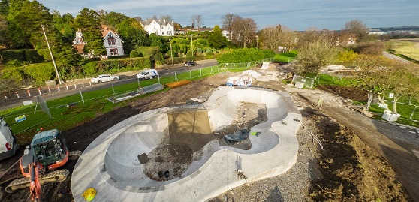  - Ensured that environmental consideration was taken during the planning application for the new skatepark on the promenade. Wildflower seeds will be sewn, and SUDS is incorporated into the design. There will be a hedgerow planted on the road side of the skatepark to encourage biodiversity and connect Swansea Council’s Swansea Bay wildlife corridor.  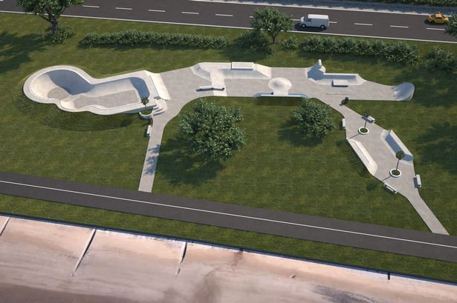  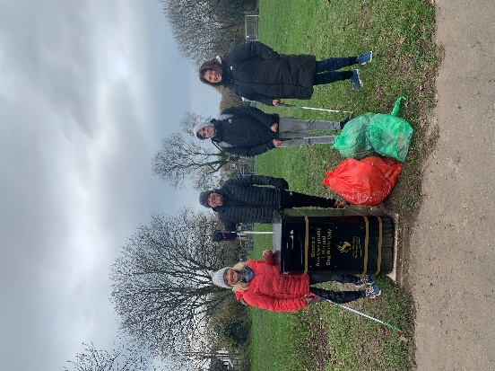  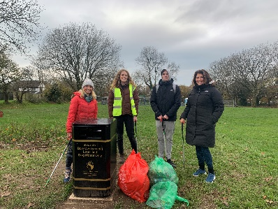  - Working with Keep Wales Tidy and becoming a litter free zone. Our obligations as a litter free zone include keeping our buildings and green space litter free and committing to regular litter picks in our local area, which we are carrying out in each ward once per month.  - Continued work of the environmental committee who meet once per month and are a voice in the community to advocate for environmental protection.  - Setting up as a litter picking hub. This will allow members of the public to collect litter picking equipment and carry out their own litter picks in their local area.  - Declared a local Climate Emergency and commitment to developing greener initiatives locally.  - Environmental and Sustainability Engagement Officer and Grounds Person appointed to give advice on projects.  - We are consulting Down to Earth (a local architect service with biodiversity at the heart of its values) on the development of a new council building which will have sustainable building practices and biodiversity at the forefront of development.  - Insistence that Swansea Council avoid pesticides in our area.  - Plans to implement SUDS where possible in the area to support inefficient traditional drainage systems. | Commitment made in documents  Meeting minutes on our website  Commitment and resolution letter on our website
-raise awareness of biodiversity & its importance | - Forest school will be held twice per week in new year by Oystermouth Primary School at Norton Nature Reserve and Community Gardens.  - Plans to create a sheltered outdoor learning area at the National Lottery Funded Norton Nature Reserve and Community Gardens.  - MCC environmental Instagram made to promote our environmental initiatives and to create a platform for sharing work.  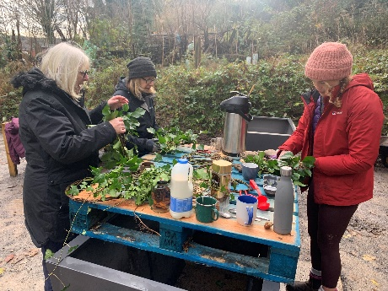  - Development of a regular volunteer group, providing a range of tasks and activities to involve the public in the development of biodiverse green spaces.  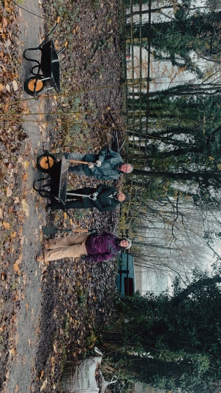  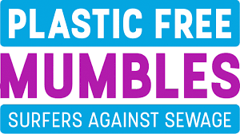  - Continuation of the Plastic Free Mumbles Campaign.  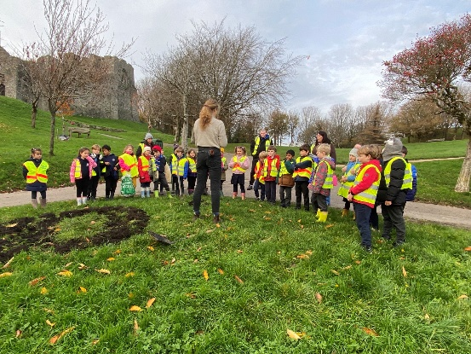  - Bulb planting days involving local community groups and schools.  - Educational interpretation panels in Norton Nature Reserve and Community Gardens displaying facts about the varied habitats and inspiration for how people can improve biodiversity in their own outdoor spaces.  - Collaboration with the Orchard Project to provide training days for volunteers to equip them with conservation management skills and knowledge.  - Continuation of Environmental and Sustainability Engagement officer role to raise awareness and encourage the community to engage, use, volunteer and learn about their local environment.  - Redesign of environmental section of our website planned to clearly display details of our environmental projects.  - Social media platforms dedicated to wildlife communication and environmental engagement. | Our Environmental Engagement Officer and social media engagements.
-safeguard principal species and habitats | - Norton Nature Reserve and Community Gardens grant obtained, allowing us to transform an abandoned space with limited biodiversity into a haven for wildlife, providing safe, productive habitats for a range of species.  - Hedgerows will be planted at the new skatepark site to connect the Swansea Bay wildlife corridor.  - Ecology report conducted by Sazer Ecology. This identified already established species from the previous year for us to acknowledge and support them in our habitat creation. | National lottery grant report.  Environmental and Sustainability Engagement Officer.  Further ecological reports.
-restore & create habitats and resilient ecological networks | - Bulb planting in each ward of Mumbles.  - National Lottery Heritage Funding approved and work in progress for Norton Nature Reserve and Community Garden developed to include an example of various habitats to encourage biodiversity. These include woodland, wildflower, wetland, pond, deadwood and shrub habitats. A wildlife corridor developed to connect habitats to local woodland.  - Dead hedging at Norton Nature Reserve and Community Gardens and Community Orchard.  - Attained ownership of a number of neglected green spaces in order to restore them to areas of high biodiversity and environmental importance.  - Grounds person appointed for habitat management and maintenance of newly attained green spaces.  - Worked with Swansea Council to install wildflower strips around the community.  - Working with the Orchard Project to restore a traditional orchard. | Environmental and Sustainability Engagement Officer.  Further ecological reports.  Environmental Committee meetings.
-tackle negative factors: for e.g. reduce pollution, use nature based solutions,  address invasive species | - Regular litter picks in local area as part of becoming a Litter Free Zone through Keep Wales Tidy.  - Ecological report at Norton Nature Reserve and Community Gardens highlighting invasive species to be removed.  - Opening as a litter picking hub to provide equipment and support for people to arrange their own litter picks in the local area. | Environmental and Sustainability Engagement Officer.  Environmental Committee meetings.
-use improve and share evidence | - Working with Swansea Council and Hubbub to replace and implement new recycling bins and a local campaign to increase knowledge of these issues.  - Reporting litter picking data to Keep Wales Tidy through Epicollect app. | Environmental and Sustainability Engagement Officer.  Environmental Committee meetings.  Epicollect app (Keep Wales Tidy)
-support capacity and/or other organisations | - Plans to add an eco-friendly business list to our website to direct residents to local environmentally friendly businesses.  - Collaborations with local initiatives and organisations including:  - Keep Wales Tidy.  - Plantlife.  - Surfers Against Sewage.  - Swansea Council.  - The Orchard Project.  - Local artists.  - City of Sanctuary.  - The Sunflower Lounge. | Environmental and Sustainability Engagement Officer.  Website updates.

Review of s6 duty
- What has worked well?
- Norton Nature Reserve close to completion with a successful array of habitats encouraging wildlife and enhancing biodiversity in the local community. The community are excited for the opening and to see what positive impact it will have on the community.
- Volunteering group established by the Environmental and Sustainability Engagement Officer, with plans to collaborate with organisations such as City of Sanctuary and local schools.
- Bulbs planted in different wards to provide early pollen for pollinators.
- Our environmental engagement campaigns, activities and initiatives are reaching more members of the public and attitudes in the local area seem to be geared more and more to supporting biodiversity.

- What have the barriers been?

- Covid 19 has impacted the amount of physical engagement that volunteers feel comfortable with, therefore we have developed our online profiles more over the last few years.
- Extreme weather conditions, including extreme heat and drought in summer and heavy downpours in Autumn have meant that physical grounds work and growing has been difficult. The changing behavioural adaptions of wildlife has also meant we have had to adapt our approach in some projects.

- What will you change?

We will continue connecting with local groups and organisations through outdoor learning programmes, volunteering and community-based initiatives. We will provide more activity-based engagement days to encourage more community members to change their mindset on how they use and view the natural world around them. We will incorporate more green infrastructure in the area, showcasing biodiversity improvement and reducing energy consumption where we can.

- How and when will the s6 duty be monitored and the s6 plan reviewed?

The duty and objectives will be monitored by the Environmental Committee, who will meet once per month. The Environmental and Sustainability Engagement Officer will report back to this committee at each meeting with an update on actions taken that month. These meetings and their outcomes will be publicised on our website for community members to engage with.
We will aim to review and reflect on this report yearly.

